Computer Games Programming
Tutorial 04 - Bitmaps and Fonts

Introduction

Last week you created a default SDL 2 project, learnt how to initialise a display and clear it to a colour, and finally you set up an event handler that monitored keypresses. This time you will learn how to load and display both bitmaps and fonts, both of which are fundamental to the creation of 2D games graphics.

Bitmaps

A bitmap is a square or rectangular collection of RGB coloured pixels that represent an image. Here, for example, is a bitmap that represents a pink haired, red eyed alien with green tentacles:
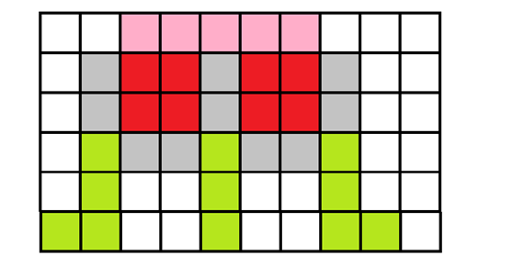
Of course this is a very simple and low resolution example, most bitmaps used would consist of more colours and pixels. A bitmap image is stored in a file, the examples in this tutorial use the .bmp format, but there are others such as .tga that can be used. The number of colours that can be represented by each pixel varies based on the file format used, but in general in SDL2 you can assume that each RGB component can vary from 0 to 255, much as you saw when clearing the screen to different colours in the last tutorial.

The following code shows how to load and display bitmaps on screen:

First up, we’re going to create and use a new class called Bitmap. Here’s the class declaration:
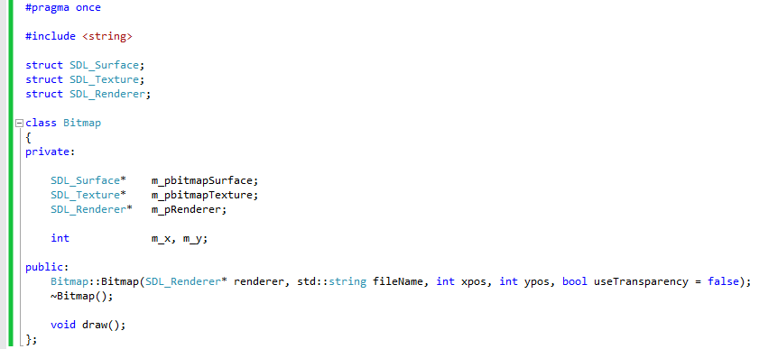

Now onto the Bitmap class’ source file (bitmap.cpp), which deals with the setting up and displaying of a bitmap on screen. We start with the necessary includes:

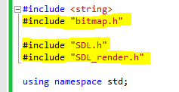

Bitmap.h obviously contains the class declaration for Bitmap. To use the image functionality of SDL 2 you first need to include both the “SDL.h” file (which we’ve used before) and a new header file named SDL_render.h.

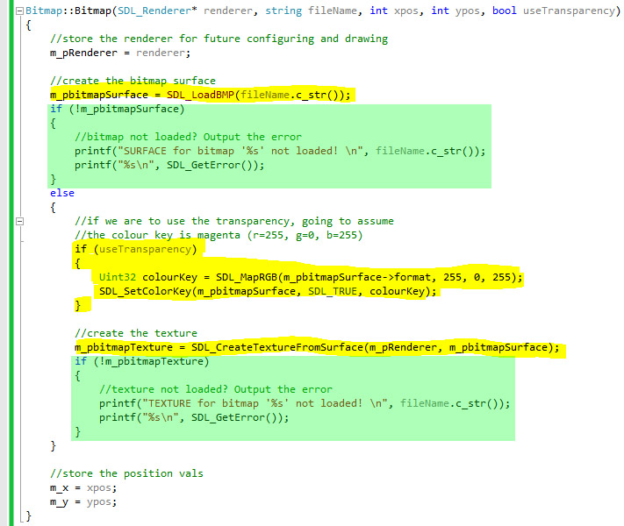

We use SDL_LoadBitmap() to load a bitmap image from a file into a member variable, m_pbitmapSurface. From the header file, we can see m_pbitmapSurface is a pointer to an SDL_Surface structure, which is basically a container for the raw pixels we want to display.

We’ll talk about the if(useTransparency) section later on, and instead go straight on to creating the texture.

By creating a texture, we’re converting our raw pixels to something more efficient that the rendering drivers can quickly deal with. Rendering textures involved copying pixel data from one memory location to another (a process is more commonly called blitting), and it pays to make the process as efficient –and therefore as fast - as possible.

With a texture created, we’re ready to display it.

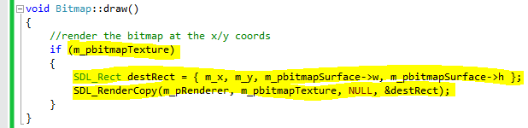

When drawing, we need to specify where on the screen we want to draw our bitmap, and how big we want our bitmap to appear. We need to set up an SDL_Rect to store these values. You can see we’ve specified the original width and height of the surface as the dimensions of our final render, meaning our bitmap will appear with its original dimensions. If we want to stretch or shrink our final render, we can do so by adjusting the width and height values stored in this SDL_Rect.

Once set up, SDL_RenderCopy() is called to copy our bitmap info to the renderer.

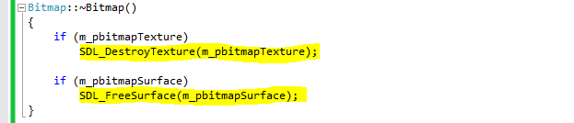

When we’re done with the bitmap, we need to free the memory allocated. Don’t forget, good practice is to destroy in reverse order in which it was created.

So that will get our bitmap info to the renderer … but we need to load the images in order to get them on screen. Let’s do that in the game class.

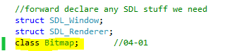

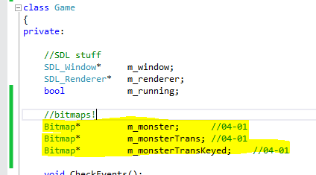

We’ve added some Bitmap member variables to the class declaration.

Here are the changes we’ve made to Game.cpp source file:

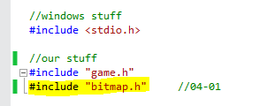

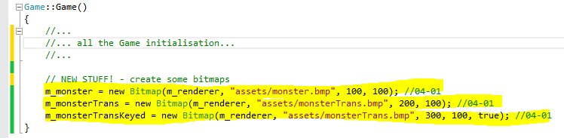

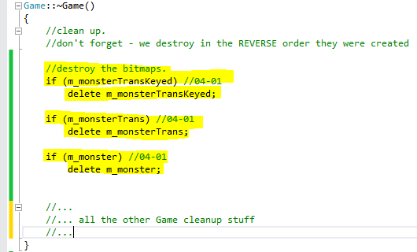

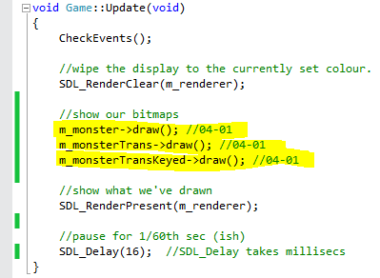

This code assumes that the images monster.bmp and monstertrans.bmp, which can be found in the "tutorial 04 assets.zip" file on myCourse, are in a folder called assets in the project folder. When run, the code should display the bitmap images in this fashion:

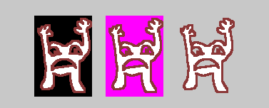

Transparent Pixels

Let’s go back to the if(useTransparency) section in the Bitmap constructor.

In the above example monster.bmp is drawn first. As you can see this image has a black border which is visible when drawn. In many cases you won't want this border to be drawn as it will overwrite images behind it, making the display look unpleasant. The way around this is to give the bitmap image transparent pixels.

The third bitmap we draw (m_monsterTransKeyed) calls the Bitmap constructor with the useTransparency bool set to true. This tells the Bitmap constructor to set up what’s known as a Colour Key for the bitmap:

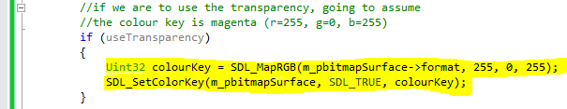

By creating a colour key and applying it to the surface, we are converting all pixels in the bitmap that have the same colour as the colour key to be transparent. The colour key can be any RGB value, but we choose bright magenta because it’s obvious and because no self-respecting artist would ever intentionally use it in a piece of artwork.

This is shown in images 2 and 3 using the monstertrans.bmp bitmap. The second image shows the bitmap drawn before the pixels are turned transparent, the colour in the border is RGB(255, 0, 255). The final image shows how the transparency works after SDL_SetColourKey()is called on the bitmap using RGB(255, 0, 255) as the transparent colour.

You can find more information on how SDL works in the online SDL wiki : https://wiki.libsdl.org/FrontPage

Exercise 01 - Moving Pictures

In this exercise you will create a simple program that moves a bitmap around the screen by pressing keys.
- Create a project called [your name] Tutorial 04 Exercise 1 based on Tutorial 03 Exercise 03 (or one of the additional exercises).
- Add an assets folder inside the project folder, and in that folder put monstertrans.bmp, or one of your own.
- Write the Bitmap class and then use it to load the monstertrans bitmap in the Game() constructor. When writing your Bitmap class, don’t forget to add safety checks to make sure the surface and texture are loaded correctly.
- Convert pixels marked as not visible to transparent.
- In the game loop use two variables to represent x and y screen positions, and update these variables using keypresses. Note: when choosing keys, avoid using the keypad keys as not all computers will have them, e.g. many laptops do not.
- Draw the bitmap at the x and y position. Take care to put the draw function in the right place - in your logbook state why you decided on the particular place in the game loop to put the draw function.
- Don't forget to destroy your bitmap objects correctly on program exit.

Fonts

A font is a set of letters, numbers and symbols in a particular style. Fonts are used to display text on-screen, and SDL 2 can use fonts created from either TrueType font files (.ttf), or fonts loaded from bitmaps.

SDL2 does not support ttf files natively, so to display fonts we need to either write our own library (doable but time consuming) or install an SDL2 extension library named SDL_ttf.

Download the SDL_ttf development libraries either from Solent Online Learning or you can go directly to the website for the latest version (https://www.libsdl.org/projects/SDL_ttf/ - download the Windows Development Libraries, not the runtime binaries)

Once done, copy the include and lib folders into your SDL directory – Windows Explorer will warn you of potential overwrites, but no files are being replaced – your suite of SDL libraries are just being added to.

You will also need to update the library dependencies for the project:

- If you cannot see the solution explorer tab, select View→Solution Explorer.
- If it is not already highlighted, click on the project (NOT on the solution), see below:
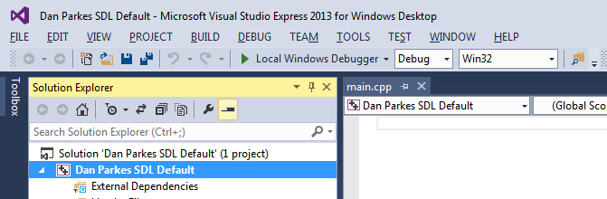

- Make sure the Configuration at the top is set to All Configurations
- Navigate to Configuration Properties→Linker→Input
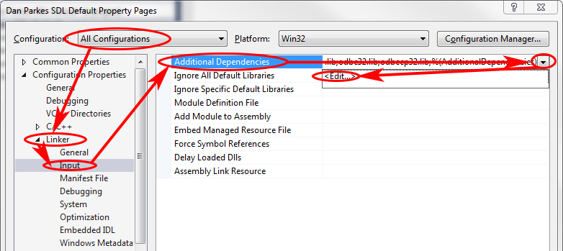

- Click on Additional Dependencies - it will highlight and display a down arrow
- Click on the down arrow - Edit should appear
- Click on Edit - the Additional Dependencies dialog should appear.
- In the top half of this dialog add :
SDL2_ttf.lib

Your dialog box should look like this:

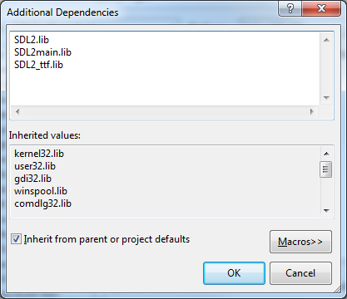

If it does, press OK.

The final step is to copy the required runtime DLLs into the project folder or edit the post build event to copy them for you.

Easy way (but you learn nothing useful)
- Navigate to the SDL\x86\lib directory
- Copy the following file
libfreetype-6.dll
SDL2_ttf.dll
zlib1.dll
- Navigate to your project folder and paste the files:

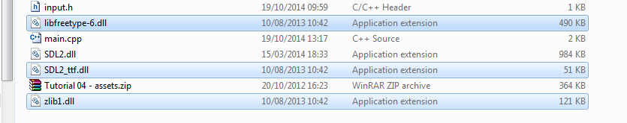

Click Ok and then Apply

The following code demonstrates how to load and display a TrueType font in SDL 2.

NOTE: This code also assumes that a file called DejaVuSans.ttf (which can be found in the "tutorial 04 assets.zip" file on myCourse) is in the assets folder.

Game class header updates:

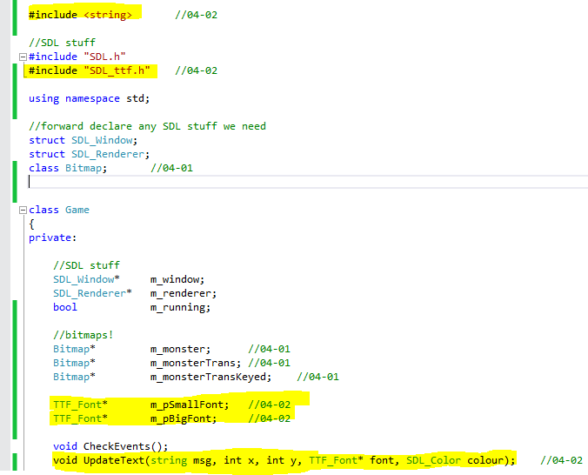

And a series of updates in the Game class source file:

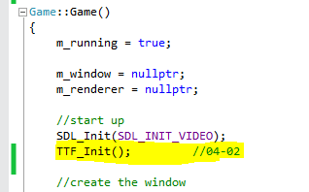

TTF_Init() initialises the font library. Do this after SDL_Init();

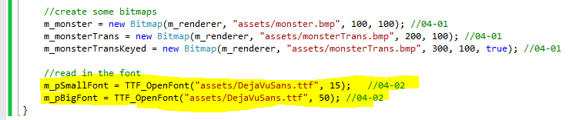

Open the fonts somewhere in the Game constructor (e.g. after the bitmaps are created) using TTF_OpenFont(). The function takes two parameters – a font file and a point size.

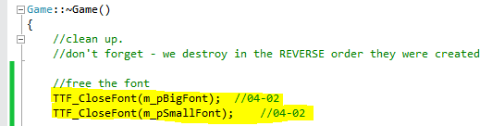

Clean up the fonts in the destructor.

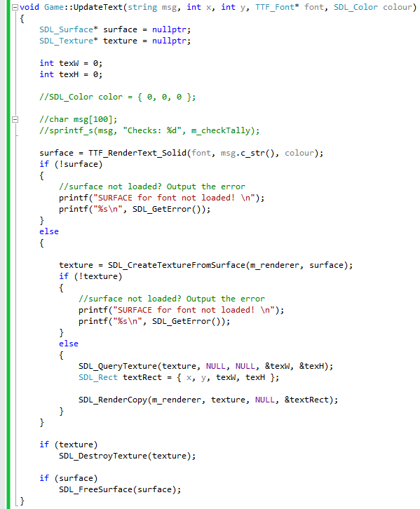

Here we have created a handy method to display text to the screen. It takes 5 parameters – the text we want to display, the screen x and y coordinates, the font we want to use and the colour of the text.

There are a couple of new functions used here which are worth going into more detail about.

Like the bitmaps, fonts require a surface and a texture to render to the screen. The surface is created using the function TTF_RenderText_Solid(), which takes the passed in font, string and colour. TTF_RenderText_Solid() takes the string in a c-style char array, so if you’re using a string container to hold your text you need to call the c_str() method to convert it into a old-school char array.

The texture is created using the SDL_CreateTextureFromSurface() function that we’ve already seen with the bitmap rendering.

Like before, we call SDL_RenderCopy() to blit our font texture to the renderer.

We are also freeing up our texture and surface at the end of the method. Our text is likely to change on a per-frame basis, so there is no point in hanging on to our created pixel information.

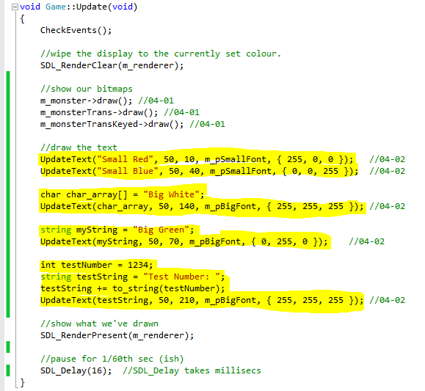
Finally, we call our UpdateText() method with a number of messages in Game::Update().

Do all the steps above, compile and run this code and you should see the following:

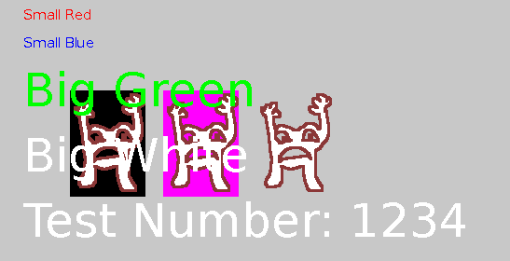

NOTE - If you use other fonts ensure that they are free to use, or you have permission, and you obey any licence restrictions.

Exercise 02 - Adding text

In this exercise you will add text output to your bitmap movement example
- Create a project called [your name] Tutorial 04 Exercise 02 based on Tutorial 04 Exercise 01
- Add the DejaVuSans.ttf True Type font to the asset folder, or one of your own.
- Add code to include and initialise the SDL2_ttf add-on, and load the font into an TTF_Font* variable. As fonts generally don't change during a game this is probably best done in the Game constructor. Be a better coder than me and add code to check if the font has been correctly loaded.
- Create an UpdateText() method and call the method with various text configurations from Game::Update().Take care to put the UpdateText() calls in the right place - in your logbook and comments state why you decided on the particular place in the game loop to put the function.
- Vary the colour of the text, either with more keypresses or programmatically.
- Don't forget to destroy the font on program exit.

Exercise 03 - Adding Creature, Hero and Monster classes

In previous sessions you wrote C++ classes representing characters in a game. Now you are going to actually make them capable of being displayed on-screen.
- Create a project called [your name] Tutorial 04 Exercise 03 based on Tutorial 04 Exercise 02.
- COPY the creature.cpp, creature.h, hero.cpp, hero.h, monster.cpp and monster.h files from the Tutorial 02 Exercise 03 folder into the Tutorial 04 Exercise 03 folder.
- Add these files to the project, either by dragging and dropping from the project folder into the project in the Solution Explorer tab in VS10, or by clicking on the project name in the Solution Explorer tab and selecting Project→Add Existing Item... from the menu bar. Your project in Solution Explorer should end up similar to this:
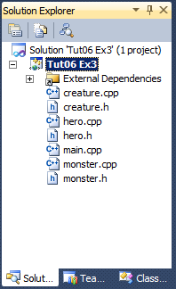
- Remove all the code in the Game class that declares and uses the bitmap from the last exercise, as well as the x and y variables and the code to draw text (keep the font creation and loading code).
- Incorporate the Bitmap class into Creature somehow – either inheriting from it or adding it as a pointer to the member variables. Which did you choose? Note your decision down in your logbook and explain your thinking.

- Modify the Creature constructor so that it takes an extra parameter representing the filename of an image, and creates the bitmap from it.
- Assume for now that all pixels that are RGB(255, 0, 255) are transparent, and convert the bitmaps pixels accordingly.
- The bitmap will have been created by dynamically allocating memory. Make sure the memory is freed when you're finished with the creature. If you’re using Bitmap as a member variable, write a method of Creature called cleanup() which destroys the bitmap.
- Modify Hero and Monster so that their constructors have a filename parameter. This filename should be passed up to the Creature constructor in the initialiser list, just like name, xpos and ypos.
- If necessary, add a draw()method to Creature that calls the bitmap’s own draw() method to render the image at the creature's current x and y position. If you’ve used inheritance to incorporate the Bitmap into the Creature class, explain in your logbook why it may not be necessary to add a draw() method to Creature;
- Include the hero and monster headers in game.cpp.
- Create a monster in the Game class. Create it in the constructor in a way similar to this:
m_pTheMonster = new Monster("BigHairyThing", 10, 10, "assets/monstertrans.bmp");

This must be AFTER SDL_Init(). Note the use of the assets/ path. Don't create object in the Update loop.
- Create a bitmap for your hero and add it to the assets folder, make sure it uses transparency.
- Create a Hero using your bitmap.
- In the game loop use the keypresses to move the hero, using the appropriate methods.
- Call the monster's chase() method with the pointer to hero as the parameter.
- At an appropriate place in the game loop call the draw() methods for both the hero and monster.
- Add a condition to the game loop that exits once the hero has been eaten().
- Add code to delete the hero and monster after the game loop is exited. Note this must be done BEFORE the SDL2 display is shut down.

